**Ride-Booking System: A Transactional Database for Mobility Service Providers**

**Table of Contents**

1. **Introduction**
2. **Application Design Requirements**
   * Login Screen
   * Driver Register Page
   * Customer Register Page
   * Customer Profile Screen
   * Book Ride Page
   * Driver Accept Ride Page
   * Payment Screen
   * Customer Previous Rides
3. **Database Normalization**

* Atomicity
* Elimination of Repeating Groups
* Unique Rows
* Elimination of Partial Dependencies
* Elimination of Transitive Dependencies
  + Referential Integrity

1. **Database Schema Overview**

* Roles Table
* Login Details Table
* Vehicles Table
* Drivers Table
* Customers Table
* Rides Table
* Ride Geolocations Table
* Payment Details Table
* Rewards Table

1. **SQL Script for Creating the MobilityServiceDB**
2. **Analytics Requirements**

**Introduction**

The Mobility Service System is a platform designed to make ride-booking and transportation services simple and efficient for both customers and drivers. Customers can create accounts, book rides, and check their ride history, while drivers can register, manage their profiles, and accept ride requests. The system supports different payment options like cash, credit cards, debit cards, and wallets, making it convenient for users. It is built with a strong database to store and manage information about users, drivers, vehicles, rides, and payments efficiently. The system also includes geolocation tracking to provide accurate ride details and ensure smooth operations. Customers and drivers can earn rewards through rides, referrals, and promotions, which adds extra benefits. With a focus on ease of use and reliability, this platform helps both users and drivers enjoy a hassle-free experience. It is designed to handle large amounts of data and can be updated or scaled as needed, making it a long-term solution for growing transportation needs.

**Application design Requirements:**

**Mock up screens**

1. **Login Screen**

This is the login page where the user will enter their username and password. If they don't have an account, they can click on "Register" to create one.

**Driver Register Page:**

To register as a driver, the user needs to select the "Register as Driver" radio button and their personal information, including username, password, first name, last name, email, phone number, and license number. Additionally, they need to enter their vehicle details in the "Vehicle Details" section, such as the vehicle type (e.g., car, motorcycle, van), license plate number, model, and capacity.

**Customer Register Page:**

To register as a customer, the user needs to select the "Register as Customer" radio button and provide their details, including username, password, first name, last name, email, and phone number. After entering the required information, they can click on "Submit" to save the details.

**Customer Profile Screen:**

On the customer profile screen, the user can view their details, including username, first name, last name, email, and phone number. They can make the changes, and then clicking "Update" to save them. The username must be unique; if the user tries to modify it to one that is already in use, an error message will be displayed.

**Book Ride Page:**

On the "Book Ride" page, the customer selects the pickup location, drop location, and vehicle type (e.g., motorcycle, cab, van). Based on the selected vehicle type, the maximum capacity and fare will be displayed. The customer can then click on "Ride" to confirm the booking. Upon confirmation, a new record will be created in the database with the status set as "Booked."

**Driver Accept Ride Page:**

After a customer books a ride, the driver can view all requested rides on the "Driver Accept Ride" page. The page displays details such as the pickup location, drop location, distance, fare, and vehicle type. The driver can review the list of available rides and accept one by clicking on the "Accept" button for a specific ride. Once the driver accepts a ride, the ride's status in the database is updated to "Accepted," and the ride is assigned to the driver. Once the driver begins the ride (picks up the customer), the status updates to **"InTransit."** When the ride is completed and the customer is dropped off at the destination, the status changes to **"Completed".** Upon completion, the customer is redirected to the **Payment Screen**,

**Payment Screen**

On the Payment Page, the customer can view the fare for the completed ride. They must select a payment option from the available methods: Cash, Credit Card, Debit Card, or Wallet. After selecting the desired payment method, the customer clicks on the "Pay" button to proceed. Upon successful payment, the payment details, including the selected payment method, fare, and transaction status and number, are recorded in the database.

**Customer Previous Rides:**

**Design Requirements:**

In the Design Requirements, we focused on planning how the Mobility Service system will work by designing its database structure. The goal was to make sure the system can handle important information like users, vehicles, drivers, customers, rides, and payments in an organized way. We ensured that each piece of data is stored properly, with no unnecessary repetition, and that all information is easy to update or delete when needed.

**Entity Relation Diagram (ERD):**

**Database Normalization:**

1. Atomicity:
   * Each column in every table holds atomic values. For example, in the drivers and customers tables, columns like phone_number and email store only one phone number or email per record, adhering to the principle of atomicity.
2. Elimination of Repeating Groups:
   * There are no repeating groups in the tables. Each column stores a single value per record. In the rides table, for instance, the columns like pickup_location, drop_location, and fare each hold a distinct value per ride. This ensures compliance with 1NF.
3. Unique Rows:
   * Each table uses primary keys to maintain uniqueness. For instance, the driver_id in the drivers table guarantees each driver is unique, and the same applies to other tables like rides and customers.
4. Elimination of Partial Dependencies:
   * In the drivers and customers tables, all non-key attributes depend entirely on their respective primary keys (driver_id and customer_id). For example, attributes like first_name, email, and phone_number in the drivers table depend solely on driver_id. This satisfies the second normal form (2NF).
5. Elimination of Transitive Dependencies:
   * The design avoids transitive dependencies. For example, in the drivers table, attributes like email, phone_number, and vehicle_id depend directly on driver_id and not on other non-key attributes. This ensures compliance with 3NF.
6. Referential Integrity:
   * Foreign keys are correctly set up to maintain referential integrity across all tables. For example, ride_id in the payment_details table references rides(ride_id), ensuring that payment details are tied to valid rides. Similarly, user_id in the rewards table ensures that rewards are linked to valid users.

**Database Schema Overview:**

**1. Roles Table**

* **Columns**:
  + role_id (Primary Key) - Unique identifier for each role.
  + role_name - Name of the role (e.g., 'Admin', 'Driver', 'Customer').
* **Primary Key**:
  + role_id
* **Foreign Keys**: None

**2. Login Details Table**

* **Columns**:
  + user_id (Primary Key) - Unique identifier for each user.
  + username - User's login name (must be unique).
  + password - User's password.
  + last_login_at - Timestamp for the last time the user logged in.
  + role_id (Foreign Key) - References roles(role_id), indicating the user's role.
* **Primary Key**:
  + user_id
* **Foreign Keys**:
  + role_id references roles(role_id)

**3. Vehicles Table**

* **Columns**:
  + vehicle_id (Primary Key) - Unique identifier for each vehicle.
  + vehicle_type - Type of vehicle (e.g., 'Sedan', 'SUV').
  + capacity - Maximum capacity of passengers the vehicle can hold.
  + license_plate - Unique vehicle license plate number.
  + model - Model of the vehicle.
  + make - Make or manufacturer of the vehicle.
  + year - Year of manufacture.
* **Primary Key**:
  + vehicle_id
* **Foreign Keys**: None

**4. Drivers Table**

* **Columns**:
  + driver_id (Primary Key) - Unique identifier for each driver.
  + first_name - Driver's first name.
  + middle_name - Driver's middle name (optional).
  + last_name - Driver's last name.
  + email - Driver's email address (unique).
  + phone_number - Driver's phone number.
  + license_number - Unique license number for the driver.
  + vehicle_id (Foreign Key) - References vehicles(vehicle_id), indicating which vehicle the driver is assigned to.
  + is_active - Indicates whether the driver is active (boolean).
  + date_joined - Timestamp of when the driver joined.
* **Primary Key**:
  + driver_id
* **Foreign Keys**:
  + vehicle_id references vehicles(vehicle_id)
  + user_id (from login_details) references login_details(user_id) as a foreign key for authentication.

**5. Customers Table**

* **Columns**:
  + customer_id (Primary Key) - Unique identifier for each customer.
  + first_name - Customer's first name.
  + middle_name - Customer's middle name (optional).
  + last_name - Customer's last name.
  + email - Customer's email address (unique).
  + phone_number - Customer's phone number.
  + date_registered - Timestamp of when the customer registered.
  + is_active - Indicates whether the customer is active (boolean).
* **Primary Key**:
  + customer_id
* **Foreign Keys**:
  + user_id (from login_details) references login_details(user_id) as a foreign key for authentication.

**6. Rides Table**

* **Columns**:
  + ride_id (Primary Key) - Unique identifier for each ride.
  + driver_id (Foreign Key) - References drivers(driver_id), indicating the driver for the ride.
  + customer_id (Foreign Key) - References customers(customer_id), indicating the customer for the ride.
  + pickup_location - Location where the ride starts.
  + drop_location - Location where the ride ends.
  + distance - Distance traveled during the ride (in kilometers or miles).
  + fare - Fare charged for the ride.
  + date - Timestamp of when the ride was booked or completed.
  + customer_rating - Rating given by the customer (if applicable).
  + comments - Optional comments provided by the customer.
  + status - Status of the ride (e.g., 'InTransit', 'Completed', 'Cancelled').
* **Primary Key**:
  + ride_id
* **Foreign Keys**:
  + driver_id references drivers(driver_id)
  + customer_id references customers(customer_id)

**7. Ride Geolocations Table**

* **Columns**:
  + route_id (Primary Key) - Unique identifier for each geolocation record.
  + ride_id (Foreign Key) - References rides(ride_id), linking geolocation data to a ride.
  + latitude - Latitude of the location point.
  + longitude - Longitude of the location point.
  + timestamp - Timestamp of when the geolocation data was recorded.
* **Primary Key**:
  + route_id
* **Foreign Keys**:
  + ride_id references rides(ride_id)

**8. Payment Details Table**

* **Columns**:
  + payment_id (Primary Key) - Unique identifier for each payment.
  + ride_id (Foreign Key) - References rides(ride_id), linking payment details to a ride.
  + payment_method - Method used for payment (e.g., 'Cash', 'CreditCard', 'DebitCard', 'Wallet').
  + amount - Amount paid for the ride.
  + transaction_status - Status of the transaction (e.g., 'Pending', 'Completed', 'Failed').
  + transaction_id - Unique transaction identifier for the payment.
  + payment_date - Timestamp of when the payment was made.
* **Primary Key**:
  + payment_id
* **Foreign Keys**:
  + ride_id references rides(ride_id)

**9. Rewards Table**

* **Columns**:
  + reward_id (Primary Key) - Unique identifier for each reward.
  + user_id (Foreign Key) - References login_details(user_id), linking the reward to the user.
  + points_earned - Number of points earned for the reward.
  + category - Category of the reward (e.g., 'Ride', 'Referral', 'Promotion').
  + description - Description of how the reward was earned.
  + date_earned - Timestamp of when the reward was earned.
* **Primary Key**:
  + reward_id
* **Foreign Keys**:
  + user_id references login_details(user_id) (for drivers, customers, and rewards)

**SQL script for creating the MobilityServiceDB:**

CREATE DATABASE MobilityServiceDB;

use MobilityServiceDB;

**-- Table Creation**

CREATE TABLE roles (

role_id INTEGER PRIMARY KEY AUTO_INCREMENT,

role_name VARCHAR(50) UNIQUE NOT NULL

);

CREATE TABLE login_details (

user_id INTEGER PRIMARY KEY AUTO_INCREMENT,

username VARCHAR(50) UNIQUE NOT NULL,

password VARCHAR(255) NOT NULL,

last_login_at TIMESTAMP DEFAULT CURRENT_TIMESTAMP,

role_id INTEGER NOT NULL, -- Ensure role_id is INTEGER

FOREIGN KEY (role_id) REFERENCES roles(role_id) ON DELETE CASCADE

);

CREATE TABLE vehicles (

vehicle_id INTEGER PRIMARY KEY AUTO_INCREMENT,

vehicle_type VARCHAR(20) NOT NULL,

capacity INTEGER NOT NULL,

license_plate VARCHAR(20) UNIQUE NOT NULL,

model VARCHAR(50) NOT NULL,

make VARCHAR(50) NOT NULL,

year INTEGER NOT NULL

);

CREATE TABLE drivers (

driver_id INTEGER PRIMARY KEY,

first_name VARCHAR(50) NOT NULL,

middle_name VARCHAR(50),

last_name VARCHAR(50) NOT NULL,

email VARCHAR(100) UNIQUE NOT NULL,

phone_number VARCHAR(15) NOT NULL,

license_number VARCHAR(50) UNIQUE NOT NULL,

vehicle_id INTEGER,

is_active BOOLEAN DEFAULT TRUE,

date_joined TIMESTAMP DEFAULT CURRENT_TIMESTAMP,

FOREIGN KEY (driver_id) REFERENCES login_details(user_id) ON DELETE CASCADE,

FOREIGN KEY (vehicle_id) REFERENCES vehicles(vehicle_id) ON DELETE SET NULL

);

CREATE TABLE customers (

customer_id INTEGER PRIMARY KEY,

first_name VARCHAR(50) NOT NULL,

middle_name VARCHAR(50),

last_name VARCHAR(50) NOT NULL,

email VARCHAR(100) UNIQUE NOT NULL,

phone_number VARCHAR(15) NOT NULL,

date_registered TIMESTAMP DEFAULT CURRENT_TIMESTAMP,

is_active BOOLEAN DEFAULT TRUE,

FOREIGN KEY (customer_id) REFERENCES login_details(user_id) ON DELETE CASCADE

);

CREATE TABLE rides (

ride_id INTEGER PRIMARY KEY AUTO_INCREMENT,

driver_id INTEGER NOT NULL,

customer_id INTEGER NOT NULL,

pickup_location VARCHAR(255) NOT NULL,

drop_location VARCHAR(255) NOT NULL,

distance FLOAT NOT NULL,

fare FLOAT NOT NULL,

date TIMESTAMP DEFAULT CURRENT_TIMESTAMP,

customer_rating FLOAT,

comments TEXT,

status VARCHAR(50) CHECK (status IN ('Booked','Accepted','InTransit', 'Completed', 'Cancelled')) NOT NULL,

FOREIGN KEY (driver_id) REFERENCES drivers(driver_id) ON DELETE CASCADE,

FOREIGN KEY (customer_id) REFERENCES customers(customer_id) ON DELETE CASCADE

);

CREATE TABLE ride_geolocations (

route_id INTEGER PRIMARY KEY AUTO_INCREMENT,

ride_id INTEGER NOT NULL,

latitude FLOAT NOT NULL,

longitude FLOAT NOT NULL,

timestamp TIMESTAMP DEFAULT CURRENT_TIMESTAMP,

FOREIGN KEY (ride_id) REFERENCES rides(ride_id) ON DELETE CASCADE

);

CREATE TABLE payment_details (

payment_id INTEGER PRIMARY KEY AUTO_INCREMENT,

ride_id INTEGER NOT NULL,

payment_method VARCHAR(20) CHECK (payment_method IN ('Cash', 'CreditCard', 'DebitCard', 'Wallet')) NOT NULL,

amount FLOAT NOT NULL,

transaction_status VARCHAR(20) CHECK (transaction_status IN ('Pending', 'Completed', 'Failed')) NOT NULL,

transaction_id VARCHAR(100) UNIQUE,

payment_date TIMESTAMP DEFAULT CURRENT_TIMESTAMP,

FOREIGN KEY (ride_id) REFERENCES rides(ride_id) ON DELETE CASCADE

);

CREATE TABLE rewards (

reward_id INTEGER PRIMARY KEY AUTO_INCREMENT,

user_id INTEGER NOT NULL,

points_earned INTEGER NOT NULL,

category VARCHAR(20) CHECK (category IN ('Ride', 'Referral', 'Promotion')) NOT NULL,

description TEXT,

date_earned TIMESTAMP DEFAULT CURRENT_TIMESTAMP,

FOREIGN KEY (user_id) REFERENCES login_details(user_id) ON DELETE CASCADE

);

-- Index Creation

-- CREATE INDEX idx_role_name ON roles (role_name);

-- CREATE INDEX idx_username ON login_details (username);

-- CREATE INDEX idx_role_id ON login_details (role_id);

-- CREATE INDEX idx_license_plate ON vehicles (license_plate);

-- CREATE INDEX idx_vehicle_type ON vehicles (vehicle_type);

-- CREATE INDEX idx_license_number ON drivers (license_number);

-- CREATE INDEX idx_vehicle_id ON drivers (vehicle_id);

-- CREATE INDEX idx_customer_email ON customers (email);

-- CREATE INDEX idx_driver_id ON rides (driver_id);

-- CREATE INDEX idx_customer_id ON rides (customer_id);

-- CREATE INDEX idx_status ON rides (status);

-- CREATE INDEX idx_ride_id ON ride_geolocations (ride_id);

-- CREATE INDEX idx_ride_id_payment ON payment_details (ride_id);

-- CREATE INDEX idx_transaction_status ON payment_details (transaction_status);

-- CREATE INDEX idx_payment_method ON payment_details (payment_method);

-- CREATE INDEX idx_user_id ON rewards (user_id);

-- CREATE INDEX idx_category ON rewards (category);

-- Data insert statements

INSERT INTO roles (role_name) VALUES ('Admin'), ('Driver'), ('Customer');

INSERT INTO vehicles (vehicle_type, capacity, license_plate, model, make, year)

VALUES

('Truck', 2, 'US-TRK001', 'Model X', 'Tesla', 2023),

('Van', 8, 'US-VAN002', 'Transit', 'Ford', 2022),

('Truck', 4, 'US-TRK003', 'F-150', 'Ford', 2021),

('Van', 10, 'US-VAN004', 'Odyssey', 'Honda', 2020),

('Truck', 3, 'US-TRK005', 'RAM 1500', 'Dodge', 2023),

('Van', 12, 'US-VAN006', 'Pacifica', 'Chrysler', 2021),

('Truck', 5, 'US-TRK007', 'Silverado', 'Chevrolet', 2020),

('Van', 9, 'US-VAN008', 'Sienna', 'Toyota', 2021),

('Truck', 6, 'US-TRK009', 'Tundra', 'Toyota', 2022),

('Van', 7, 'US-VAN010', 'Sprinter', 'Mercedes-Benz', 2023),

('Truck', 2, 'US-TRK011', 'Ram 2500', 'Dodge', 2022),

('Van', 10, 'US-VAN012', 'Viano', 'Mercedes-Benz', 2020),

('Truck', 3, 'US-TRK013', 'Hino 300', 'Hino', 2021),

('Van', 8, 'US-VAN014', 'Metris', 'Mercedes-Benz', 2022),

('Truck', 4, 'US-TRK015', 'Isuzu D-Max', 'Isuzu', 2020),

('Van', 6, 'US-VAN016', 'Transit Connect', 'Ford', 2023),

('Truck', 5, 'US-TRK017', 'Ford Ranger', 'Ford', 2021),

('Van', 9, 'US-VAN018', 'Express 3500', 'Chevrolet', 2020),

('Truck', 7, 'US-TRK019', 'Freightliner M2', 'Freightliner', 2023),

('Van', 8, 'US-VAN020', 'NV3500', 'Nissan', 2022);

-- Inserting login details for drivers with passwords based on username and special characters

INSERT INTO login_details (username, password, role_id)

VALUES

('john_doe', 'john_doe@123', 2),

('jane_smith', 'jane_smith#456', 2),

('michael_johnson', 'michael_johnson!789', 2),

('emily_williams', 'emily_williams$012', 2),

('david_brown', 'david_brown%345', 2),

('sophia_jones', 'sophia_jones^678', 2),

('james_miller', 'james_miller&910', 2),

('isabella_davis', 'isabella_davis*112', 2),

('william_garcia', 'william_garcia+131', 2),

('olivia_martinez', 'olivia_martinez@141', 2),

('benjamin_hernandez', 'benjamin_hernandez#151', 2),

('mia_lopez', 'mia_lopez$161', 2),

('lucas_gonzalez', 'lucas_gonzalez^171', 2),

('charlotte_perez', 'charlotte_perez!181', 2),

('alexander_wilson', 'alexander_wilson@191', 2),

('amelia_anderson', 'amelia_anderson#202', 2),

('ethan_thomas', 'ethan_thomas*212', 2),

('harper_taylor', 'harper_taylor+222', 2),

('logan_moore', 'logan_moore$232', 2),

('grace_jackson', 'grace_jackson!242', 2);

-- Inserting login details for customers with passwords based on username and special characters

INSERT INTO login_details (username, password, role_id)

VALUES

('liam_parker', 'liam_parker@252', 3),

('emma_roberts', 'emma_roberts#262', 3),

('aiden_mitchell', 'aiden_mitchell!272', 3),

('olivia_harris', 'olivia_harris$282', 3),

('noah_thompson', 'noah_thompson^292', 3),

('mia_garcia', 'mia_garcia*302', 3),

('ethan_lee', 'ethan_lee+312', 3),

('sophia_martin', 'sophia_martin@322', 3),

('lucas_taylor', 'lucas_taylor#332', 3),

('charlotte_young', 'charlotte_young!342', 3),

('jackson_moore', 'jackson_moore$352', 3),

('amelia_adams', 'amelia_adams^362', 3),

('oliver_carter', 'oliver_carter*372', 3),

('harper_baker', 'harper_baker+382', 3),

('evan_scott', 'evan_scott@392', 3),

('chloe_nelson', 'chloe_nelson#402', 3),

('mason_hill', 'mason_hill!412', 3),

('ella_green', 'ella_green$422', 3),

('gabriel_king', 'gabriel_king^432', 3),

('grace_wright', 'grace_wright*442', 3);

INSERT INTO drivers (driver_id, first_name, middle_name, last_name, email, phone_number, license_number, vehicle_id, is_active, date_joined)

VALUES

(1, 'John', 'M', 'Doe', 'john.doe@gmail.com', '1234567890', 'ABC12345', 1, TRUE, NOW()),

(2, 'Jane', 'A', 'Smith', 'jane.smith@gmail.com', '2345678901', 'DEF67890', 2, TRUE, NOW()),

(3, 'Michael', 'B', 'Johnson', 'michael.johnson@gmail.com', '3456789012', 'GHI13579', 3, TRUE, NOW()),

(4, 'Emily', 'C', 'Williams', 'emily.williams@gmail.com', '4567890123', 'JKL24680', 4, TRUE, NOW()),

(5, 'David', 'D', 'Brown', 'david.brown@gmail.com', '5678901234', 'MNO35791', 5, TRUE, NOW()),

(6, 'Sophia', 'E', 'Jones', 'sophia.jones@gmail.com', '6789012345', 'PQR46802', 6, TRUE, NOW()),

(7, 'James', 'F', 'Miller', 'james.miller@gmail.com', '7890123456', 'STU57913', 7, TRUE, NOW()),

(8, 'Isabella', 'G', 'Davis', 'isabella.davis@gmail.com', '8901234567', 'VWX68024', 8, TRUE, NOW()),

(9, 'William', 'H', 'Garcia', 'william.garcia@gmail.com', '9012345678', 'YZA79135', 9, TRUE, NOW()),

(10, 'Olivia', 'I', 'Martinez', 'olivia.martinez@gmail.com', '0123456789', 'BCD80246', 10, TRUE, NOW()),

(11, 'Benjamin', 'J', 'Hernandez', 'benjamin.hernandez@gmail.com', '1234567890', 'EFG91357', 11, TRUE, NOW()),

(12, 'Mia', 'K', 'Lopez', 'mia.lopez@gmail.com', '2345678901', 'HIJ02468', 12, TRUE, NOW()),

(13, 'Lucas', 'L', 'Gonzalez', 'lucas.gonzalez@gmail.com', '3456789012', 'KLM13579', 13, TRUE, NOW()),

(14, 'Charlotte', 'M', 'Perez', 'charlotte.perez@gmail.com', '4567890123', 'NOP24680', 14, TRUE, NOW()),

(15, 'Alexander', 'N', 'Wilson', 'alexander.wilson@gmail.com', '5678901234', 'QRS35791', 15, TRUE, NOW()),

(16, 'Amelia', 'O', 'Anderson', 'amelia.anderson@gmail.com', '6789012345', 'TUV46802', 16, TRUE, NOW()),

(17, 'Ethan', 'P', 'Thomas', 'ethan.thomas@gmail.com', '7890123456', 'WXY57913', 17, TRUE, NOW()),

(18, 'Harper', 'Q', 'Taylor', 'harper.taylor@gmail.com', '8901234567', 'ZAB68024', 18, TRUE, NOW()),

(19, 'Logan', 'R', 'Moore', 'logan.moore@gmail.com', '9012345678', 'CDE79135', 19, TRUE, NOW()),

(20, 'Grace', 'S', 'Jackson', 'grace.jackson@gmail.com', '0123456789', 'FGH80246', 20, TRUE, NOW());

INSERT INTO customers (customer_id, first_name, middle_name, last_name, email, phone_number, date_registered, is_active)

VALUES

(21, 'Liam', 'B', 'Harrison', 'liam.harrison@gmail.com', '5678901234', NOW(), TRUE),

(22, 'Emma', 'C', 'Wells', 'emma.wells@gmail.com', '6789012345', NOW(), TRUE),

(23, 'Aiden', 'M', 'Hughes', 'aiden.hughes@gmail.com', '7890123456', NOW(), TRUE),

(24, 'Olivia', 'P', 'Foster', 'olivia.foster@gmail.com', '8901234567', NOW(), TRUE),

(25, 'Noah', 'T', 'Stewart', 'noah.stewart@gmail.com', '9012345678', NOW(), TRUE),

(26, 'Mia', 'R', 'Greenwood', 'mia.greenwood@gmail.com', '0123456789', NOW(), TRUE),

(27, 'Ethan', 'V', 'Pierce', 'ethan.pierce@gmail.com', '1234567890', NOW(), TRUE),

(28, 'Sophia', 'J', 'Carlson', 'sophia.carlson@gmail.com', '2345678901', NOW(), TRUE),

(29, 'Lucas', 'K', 'Dunn', 'lucas.dunn@gmail.com', '3456789012', NOW(), TRUE),

(30, 'Charlotte', 'N', 'Manning', 'charlotte.manning@gmail.com', '4567890123', NOW(), TRUE),

(31, 'Jackson', 'F', 'Wagner', 'jackson.wagner@gmail.com', '5678901234', NOW(), TRUE),

(32, 'Amelia', 'S', 'Burns', 'amelia.burns@gmail.com', '6789012345', NOW(), TRUE),

(33, 'Oliver', 'Q', 'Douglas', 'oliver.douglas@gmail.com', '7890123456', NOW(), TRUE),

(34, 'Harper', 'B', 'Lloyd', 'harper.lloyd@gmail.com', '8901234567', NOW(), TRUE),

(35, 'Evan', 'D', 'Byrne', 'evan.byrne@gmail.com', '9012345678', NOW(), TRUE),

(36, 'Chloe', 'H', 'Fowler', 'chloe.fowler@gmail.com', '0123456789', NOW(), TRUE),

(37, 'Mason', 'T', 'Henderson', 'mason.henderson@gmail.com', '1234567890', NOW(), TRUE),

(38, 'Ella', 'N', 'Riley', 'ella.riley@gmail.com', '2345678901', NOW(), TRUE),

(39, 'Gabriel', 'W', 'Wells', 'gabriel.wells@gmail.com', '3456789012', NOW(), TRUE),

(40, 'Grace', 'M', 'Morgan', 'grace.morgan@gmail.com', '4567890123', NOW(), TRUE);

-- Insert sample ride data

-- Insert sample ride data for the previous year (2023)

INSERT INTO rides (driver_id, customer_id, pickup_location, drop_location, distance, fare, status, date)

VALUES

(1, 21, '123 Main St', '456 Elm St', 10.5, 10.0, 'Completed', '2023-01-01 10:00:00'),

(2, 22, '789 Oak St', '101 Pine St', 8.0, 5.0, 'Completed', '2023-01-05 12:30:00'),

(3, 23, '202 Birch St', '303 Cedar St', 12.3, 25.0, 'Completed', '2023-01-10 15:45:00'),

(4, 24, '404 Maple St', '505 Willow St', 5.0, 12.5, 'Completed', '2023-01-15 14:00:00'),

(5, 25, '606 Aspen St', '707 Redwood St', 6.8, 18.0, 'Completed', '2023-01-20 08:00:00'),

(6, 26, '808 Palm St', '909 Oakwood St', 9.5, 22.0, 'Completed', '2023-01-25 16:30:00'),

(7, 27, '1010 Beach St', '1111 Forest St', 15.0, 10.0, 'Completed', '2023-01-28 13:20:00'),

(8, 28, '1212 River St', '1313 Valley St', 7.2, 7.0, 'Completed', '2023-01-30 09:00:00'),

(9, 29, '1414 Mountain St', '1515 Hill St', 10.0, 70.0, 'Completed', '2023-01-30 18:00:00'),

(10, 30, '1616 Desert St', '1717 Ocean St', 14.0, 8.0, 'Completed', '2023-01-31 11:50:00'),

(1, 21, '123 Main St', '456 Elm St', 10.5, 20.0, 'Completed', '2023-02-01 10:00:00'),

(2, 22, '789 Oak St', '101 Pine St', 8.0, 15.0, 'Completed', '2023-02-05 12:30:00'),

(3, 23, '202 Birch St', '303 Cedar St', 12.3, 25.0, 'Completed', '2023-02-10 15:45:00'),

(4, 24, '404 Maple St', '505 Willow St', 5.0, 12.5, 'Completed', '2023-02-14 14:00:00'),

(5, 25, '606 Aspen St', '707 Redwood St', 6.8, 18.0, 'Completed', '2023-02-18 08:00:00'),

(6, 26, '808 Palm St', '909 Oakwood St', 9.5, 22.0, 'Completed', '2023-02-21 16:30:00'),

(7, 27, '1010 Beach St', '1111 Forest St', 15.0, 30.0, 'Completed', '2023-02-23 13:20:00'),

(8, 28, '1212 River St', '1313 Valley St', 7.2, 17.0, 'Completed', '2023-02-25 09:00:00'),

(9, 29, '1414 Mountain St', '1515 Hill St', 10.0, 20.0, 'Completed', '2023-02-28 18:00:00'),

(10, 30, '1616 Desert St', '1717 Ocean St', 14.0, 28.0, 'Completed', '2023-02-28 11:50:00'),

(1, 21, '123 Main St', '456 Elm St', 10.5, 20.0, 'Completed', '2023-03-01 10:00:00'),

(2, 22, '789 Oak St', '101 Pine St', 8.0, 15.0, 'Completed', '2023-03-05 12:30:00'),

(3, 23, '202 Birch St', '303 Cedar St', 12.3, 25.0, 'Completed', '2023-03-10 15:45:00'),

(4, 24, '404 Maple St', '505 Willow St', 5.0, 12.5, 'Completed', '2023-03-15 14:00:00'),

(5, 25, '606 Aspen St', '707 Redwood St', 6.8, 18.0, 'Completed', '2023-03-20 08:00:00'),

(6, 26, '808 Palm St', '909 Oakwood St', 9.5, 22.0, 'Completed', '2023-03-25 16:30:00'),

(7, 27, '1010 Beach St', '1111 Forest St', 15.0, 30.0, 'Completed', '2023-03-28 13:20:00'),

(8, 28, '1212 River St', '1313 Valley St', 7.2, 17.0, 'Completed', '2023-03-30 09:00:00'),

(9, 29, '1414 Mountain St', '1515 Hill St', 10.0, 20.0, 'Completed', '2023-03-30 18:00:00'),

(10, 30, '1616 Desert St', '1717 Ocean St', 14.0, 28.0, 'Completed', '2023-03-31 11:50:00'),

(1, 21, '123 Main St', '456 Elm St', 10.5, 20.0, 'Completed', '2024-01-01 10:00:00'),

(2, 22, '789 Oak St', '101 Pine St', 8.0, 15.0, 'Completed', '2024-01-05 12:30:00'),

(3, 23, '202 Birch St', '303 Cedar St', 12.3, 25.0, 'Completed', '2024-01-10 15:45:00'),

(4, 24, '404 Maple St', '505 Willow St', 5.0, 12.5, 'Completed', '2024-01-15 14:00:00'),

(5, 25, '606 Aspen St', '707 Redwood St', 6.8, 118.0, 'Completed', '2024-01-20 08:00:00'),

(6, 26, '808 Palm St', '909 Oakwood St', 9.5, 122.0, 'Completed', '2024-01-25 16:30:00'),

(7, 27, '1010 Beach St', '1111 Forest St', 15.0, 30.0, 'Completed', '2024-01-28 13:20:00'),

(8, 28, '1212 River St', '1313 Valley St', 7.2, 17.0, 'Completed', '2024-01-30 09:00:00'),

(9, 29, '1414 Mountain St', '1515 Hill St', 10.0, 20.0, 'Completed', '2024-01-30 18:00:00'),

(10, 30, '1616 Desert St', '1717 Ocean St', 14.0, 28.0, 'Completed', '2024-01-31 11:50:00'),

(1, 21, '123 Main St', '456 Elm St', 10.5, 20.0, 'Completed', '2024-02-01 10:00:00'),

(2, 22, '789 Oak St', '101 Pine St', 8.0, 15.0, 'Completed', '2024-02-05 12:30:00'),

(3, 23, '202 Birch St', '303 Cedar St', 12.3, 25.0, 'Completed', '2024-02-10 15:45:00'),

(4, 24, '404 Maple St', '505 Willow St', 5.0, 12.5, 'Completed', '2024-02-14 14:00:00'),

(5, 25, '606 Aspen St', '707 Redwood St', 6.8, 18.0, 'Completed', '2024-02-18 08:00:00'),

(6, 26, '808 Palm St', '909 Oakwood St', 9.5, 22.0, 'Completed', '2024-02-21 16:30:00'),

(7, 27, '1010 Beach St', '1111 Forest St', 15.0, 30.0, 'Completed', '2024-02-23 13:20:00'),

(8, 28, '1212 River St', '1313 Valley St', 7.2, 17.0, 'Completed', '2024-02-25 09:00:00'),

(9, 29, '1414 Mountain St', '1515 Hill St', 10.0, 20.0, 'Completed', '2024-02-28 18:00:00'),

(10, 30, '1616 Desert St', '1717 Ocean St', 14.0, 28.0, 'Completed', '2024-02-28 11:50:00'),

(1, 21, '123 Main St', '456 Elm St', 10.5, 20.0, 'Completed', '2024-03-01 10:00:00'),

(2, 22, '789 Oak St', '101 Pine St', 8.0, 15.0, 'Completed', '2024-03-05 12:30:00'),

(3, 23, '202 Birch St', '303 Cedar St', 12.3, 25.0, 'Completed', '2024-03-10 15:45:00'),

(4, 24, '404 Maple St', '505 Willow St', 5.0, 12.5, 'Completed', '2024-03-15 14:00:00'),

(5, 25, '606 Aspen St', '707 Redwood St', 6.8, 18.0, 'Completed', '2024-03-20 08:00:00'),

(6, 26, '808 Palm St', '909 Oakwood St', 9.5, 22.0, 'Completed', '2024-03-25 16:30:00'),

(7, 27, '1010 Beach St', '1111 Forest St', 15.0, 30.0, 'Completed', '2024-03-28 13:20:00'),

(8, 28, '1212 River St', '1313 Valley St', 7.2, 17.0, 'Completed', '2024-03-30 09:00:00'),

(9, 29, '1414 Mountain St', '1515 Hill St', 10.0, 20.0, 'Completed', '2024-03-30 18:00:00'),

(10, 30, '1616 Desert St', '1717 Ocean St', 14.0, 28.0, 'Completed', '2024-03-31 11:50:00');

INSERT INTO ride_geolocations (ride_id, latitude, longitude)

VALUES

(1, 40.7128, -74.0060),

(1, 40.7306, -73.9352),

(1, 40.7550, -73.9830),

(1, 40.7580, -73.9855),

(1, 40.7790, -73.9800),

(1, 40.7128, -74.0060),

(2, 34.0522, -118.2437),

(2, 34.0632, -118.2500),

(2, 34.0750, -118.2700),

(2, 34.0812, -118.2900),

(2, 34.0980, -118.3000),

(2, 34.0522, -118.2437),

(3, 41.8781, -87.6298),

(3, 41.8800, -87.6200),

(3, 41.8900, -87.6100),

(3, 41.9000, -87.6000),

(3, 41.9050, -87.5900),

(3, 41.8781, -87.6298),

(4, 29.7604, -95.3698),

(4, 29.7700, -95.3600),

(4, 29.7800, -95.3500),

(4, 29.7900, -95.3400),

(4, 29.8000, -95.3300),

(4, 29.7604, -95.3698),

(5, 51.5074, -0.1278),

(5, 51.5150, -0.1400),

(5, 51.5250, -0.1450),

(5, 51.5300, -0.1500),

(5, 51.5400, -0.1550),

(5, 51.5074, -0.1278),

(6, 48.8566, 2.3522),

(6, 48.8600, 2.3500),

(6, 48.8700, 2.3400),

(6, 48.8800, 2.3300),

(6, 48.8900, 2.3200),

(6, 48.8566, 2.3522),

(7, 52.5200, 13.4050),

(7, 52.5300, 13.4000),

(7, 52.5400, 13.3950),

(7, 52.5500, 13.3900),

(7, 52.5600, 13.3850),

(7, 52.5200, 13.4050),

(8, 37.7749, -122.4194),

(8, 37.7800, -122.4300),

(8, 37.7900, -122.4400),

(8, 37.8000, -122.4500),

(8, 37.8100, -122.4600),

(8, 37.7749, -122.4194),

(9, 34.0522, -118.2437),

(9, 34.0600, -118.2500),

(9, 34.0700, -118.2600),

(9, 34.0800, -118.2700),

(9, 34.0900, -118.2800),

(9, 34.0522, -118.2437),

(10, 40.7306, -73.9352),

(10, 40.7400, -73.9300),

(10, 40.7500, -73.9200),

(10, 40.7600, -73.9100),

(10, 40.7700, -73.9000),

(10, 40.7306, -73.9352);

INSERT INTO payment_details (ride_id, payment_method, amount, transaction_status, transaction_id)

VALUES

(1, 'CreditCard', 20.0, 'Completed', 'TXN00123'),

(2, 'Cash', 15.0, 'Completed', 'TXN00124'),

(3, 'DebitCard', 25.0, 'Completed', 'TXN00125'),

(4, 'CreditCard', 12.5, 'Completed', 'TXN00126'),

(5, 'Wallet', 18.0, 'Failed', 'TXN00127'),

(6, 'CreditCard', 22.0, 'Completed', 'TXN00128'),

(7, 'DebitCard', 30.0, 'Completed', 'TXN00129'),

(8, 'Cash', 17.0, 'Completed', 'TXN00130'),

(9, 'Wallet', 20.0, 'Completed', 'TXN00131'),

(10, 'CreditCard', 28.0, 'Completed', 'TXN00132');

INSERT INTO rewards (user_id, points_earned, category, description)

VALUES

(1, 100, 'Ride', 'Reward for completing 10 rides'),

(2, 150, 'Ride', 'Reward for completing 15 rides'),

(3, 120, 'Referral', 'Reward for referring a new customer'),

(4, 80, 'Promotion', 'Reward for using a promotional code'),

(5, 200, 'Ride', 'Reward for completing 20 rides'),

(6, 250, 'Referral', 'Reward for referring multiple customers'),

(7, 50, 'Ride', 'Reward for completing 5 rides'),

(8, 90, 'Promotion', 'Reward for participating in a promotion'),

(9, 170, 'Referral', 'Reward for referring a customer'),

(10, 60, 'Ride', 'Reward for completing 6 rides');

**Table Output Screenshots:**

**Roles Table:**

**Login Details table**

**Customers Table:**

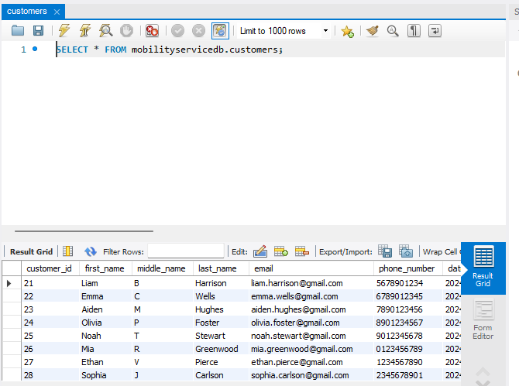

**Drivers Table:**

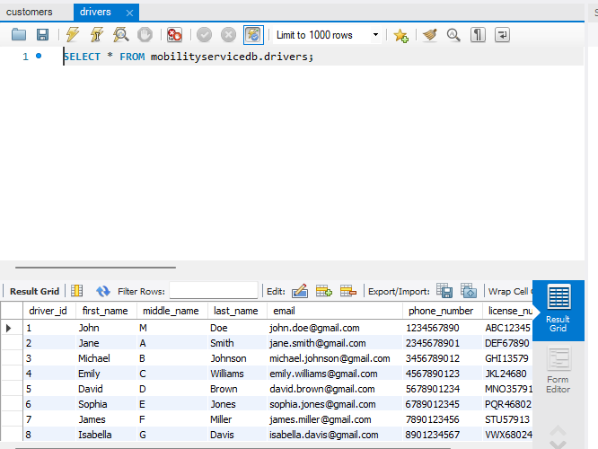

**Rides Table:**

**Ride Geo locations Table:**

**Payment Details Table:**

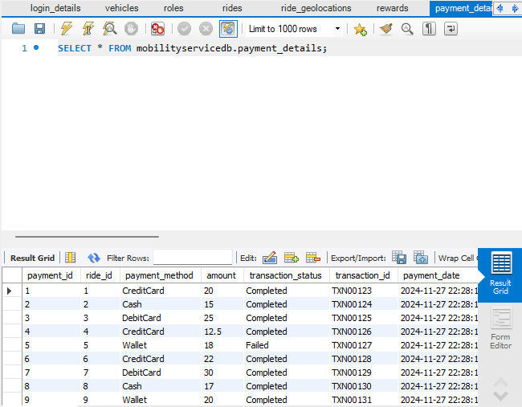

**Rewards table:**

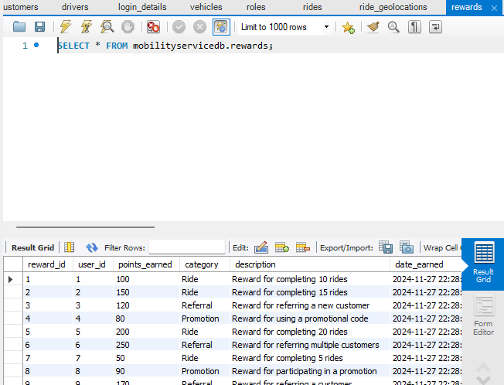

**Vehicle Table:**

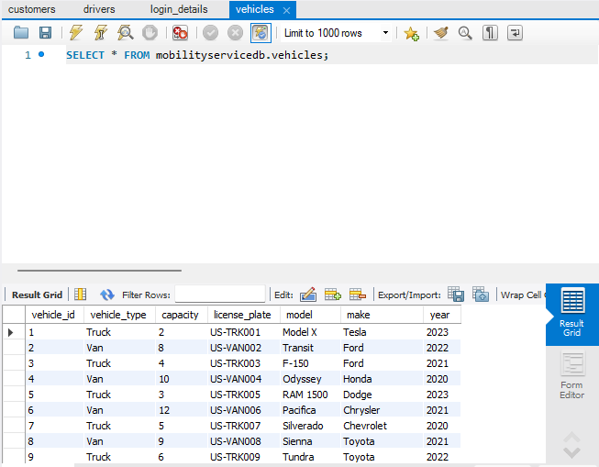

**Analytics Requirement**

**How many drivers are registered?**

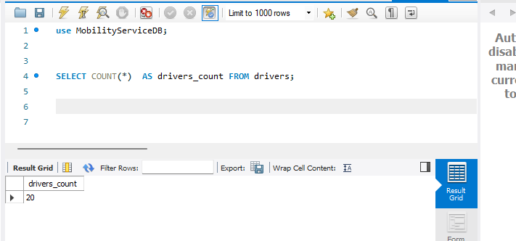

**2. Number of active vs inactive drivers this month?**

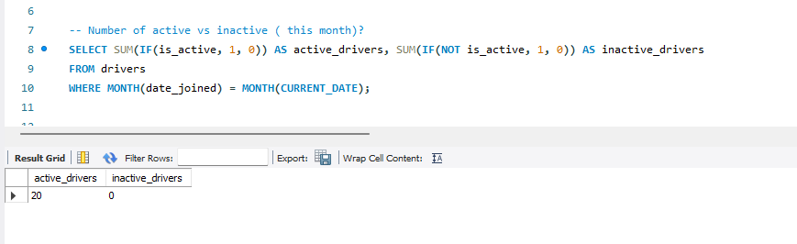

**How many customers have you registered?**

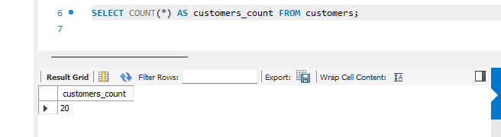

**Who is the driver with the most number of rides?**

**Who is the passenger with the most number of rides?**

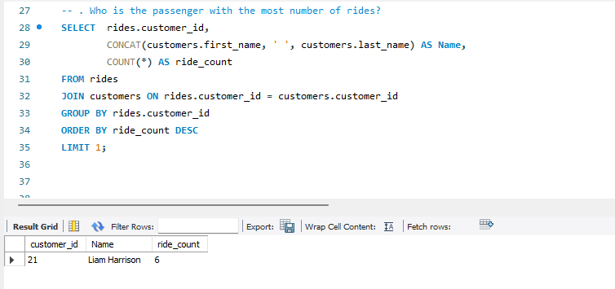

**Top 5 drivers by revenue by month (January, February, March)?**

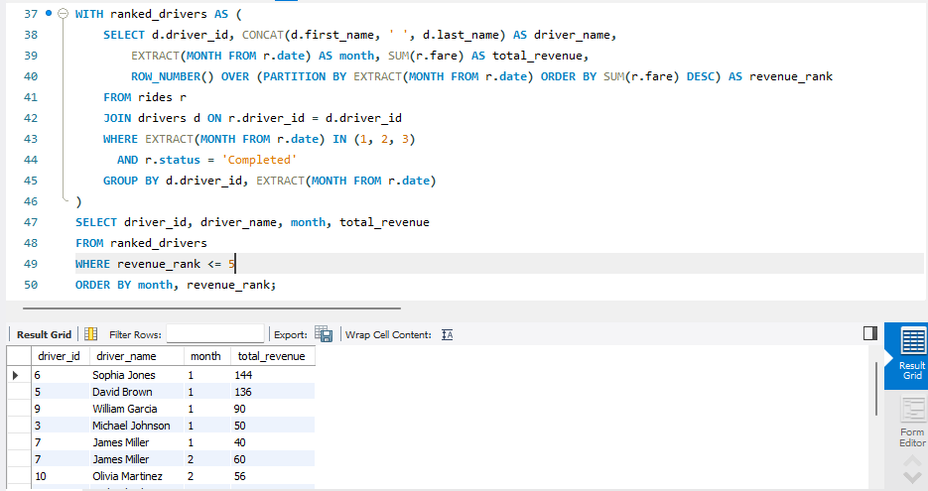

**Top 5 customers by revenue this year?**

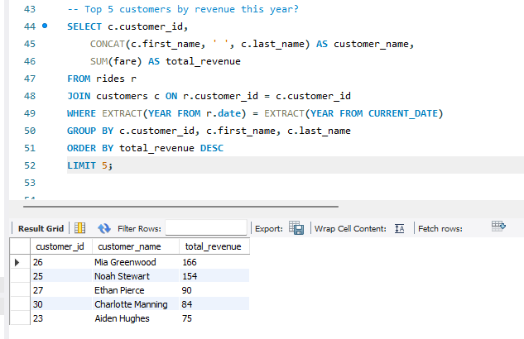

**Has our revenue increased last month compared to the same month last year?**

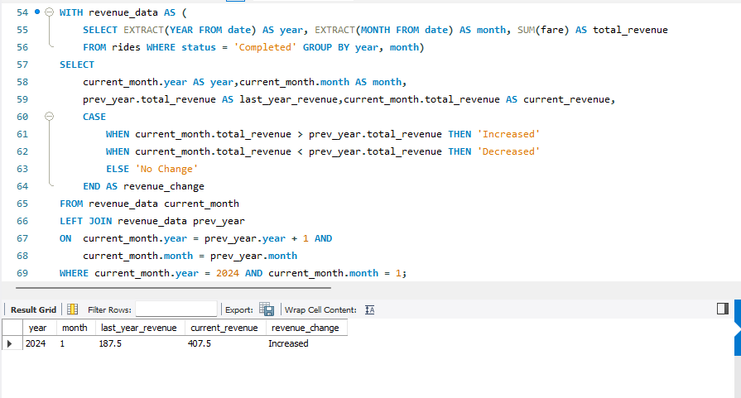

**Customer Questions:**

**What is the most expensive ride among my rides?**

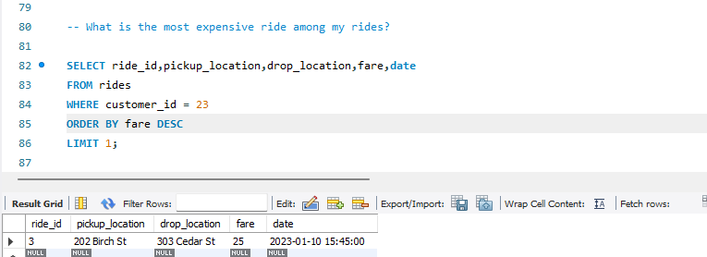

**How many rides did I take with your business?**

**How much money did I spend with your business year-to-date?**

**Operations questions**

**what is the size of project database?**

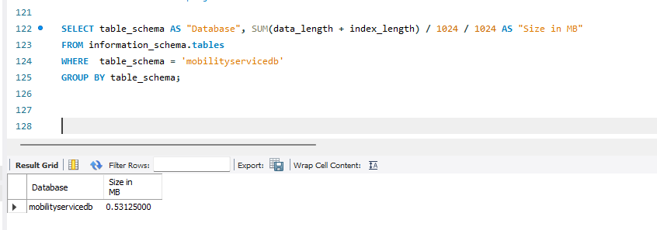

**what is the size of each table?**

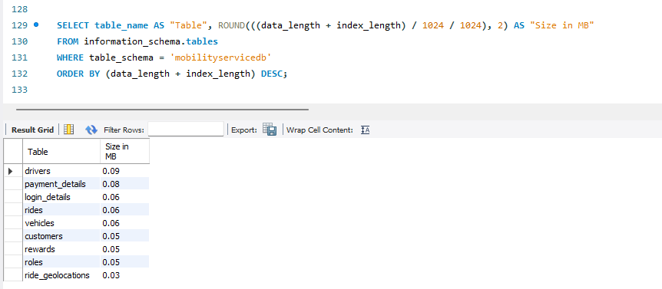

**Impact of Index Creation on Query Performance: Before and After Analysis**

Before Creating the Index:

* The query SELECT * FROM mobilityservicedb.payment_details ORDER BY payment_method LIMIT 0, 1000 was executed without an index on the payment_method column.
* Since there was no index, the database had to perform a full table scan to retrieve and order the data based on the payment_method column. This process is slower, especially as the table grows larger.

**After Creating the Index:**

* An index was created on the payment_method column using the command:

CREATE INDEX idx_payment_method ON payment_details (payment_method);

* The database now has an optimized structure to quickly locate rows based on the payment_method column. Instead of scanning the entire table, the database can efficiently access the indexed data.

**Execution Time Comparison:**

* Before index creation: The query took 0.00053950 seconds.
* After index creation: The query took 0.00047650 seconds.

The execution time improved a little after the index was created, meaning the index helped the database find and sort the data faster. However, since there are only 10 records in the table, the time difference is small. The impact of the index would be much bigger if the table had more records, making data retrieval much faster as the dataset grows.

**Conclusion:**

The Mobility Service System is designed to streamline ride-booking and transportation services, making them simple and efficient for both customers and drivers. By focusing on a well-organized database structure and proper data management, the system ensures that essential information—such as user details, vehicle information, ride records, and payment data can be stored securely and accessed easily. Through normalization, we have avoided data redundancy and maintained the integrity of the database, which supports consistent and reliable service.

With features like user registration, profile management, and a clear process for booking and accepting rides, the platform provides a smooth experience for users. The integration of payment options and reward programs enhances the overall user experience and encourages user engagement.

**References:**